FOXWELL

NEWS______________ MONTHLY NEWSLETTER_____________________________________

Fourth Issue DECEMBER 2021
COMPUTER HISTORY__  1946 - First vacuum tube-based computers developed; universities help in computer development effort; technology used in war effort.  1951 - Little technology used in schools, primarily TV; baby boom begins with resulting increases in class size; first-generation Univac computer delivered to the US census bureau.  SUCCESS_____________  Mrs. Foxwell always says, “It’s ok to make mistakes, as long as you learn from them.”  “Always remember to work hard and good things will follow.”  TIME MANAGEMENT __  When things go wrong, instead of focusing on the negative aspect, focus on making it better and you will save a lot of time to do other things. Always say to yourself, “How can I make this situation better?  “Learn to be more resourceful so you can get tasks done at a faster pace.”  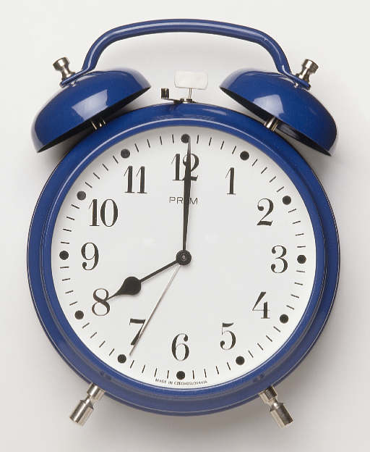 | VOCAB IN THE LAB_____________________________________  IP Number - Internet Protocol number. A unique number consisting of four parts separated by dots, for example 129.237.247.243. This is the number assigned to a host machine which is retrieved by a DNS when a request for an Internet site is made. These numbers usually correspond to unique domain names, which are easier for people to remember.  JPG or JPEG - An efficient method for storing graphic files for transmission across phone lines. Unlike GIF files, JPG files lose a little data when the image is converted, and their files are often much larger than GIFs. However, JPGs are your best choice for photographic images.  RAM - Random Access Memory. Readable and writeable memory that acts as a storage area while the computer is on, and is erased every time the computer is turned off. This memory stores data and helps execute programs while in use.  ROM - Read Only Memory. Readable memory that cannot be corrupted by accidental erasure. ROM retains its data when the computer is turned off.  TECHNOLOGY TIPS_____________________________________  Do you ever get frustrated when you type information that won’t fit on 1 page?  - Well, here’s the secret…… You can go to FILE/PAGE SETUP and reduce the top and bottom margins. You can also reduce the left and right margins and font size.  Do you spend too much money on holiday cards?  - You can create your own holiday cards. Go to the START MENU/ PROGRAMS/MICROSOFT OFFICE/ MICROSOFTPUBLISHER/DESIGN SETS/HOLIDAT SETS and choose the second card. There are four tabs at the bottom for the different pages.  HOLIDAY TIPS____________________________________  Are you having difficulties deciding which video games are safe and appropriate for your kids?  - The Entertainment Software Rating Board (ESRB) places clear motion-picture style ratings on the front of every retail box, along with descriptions of any questionable content.  - Websites such as FamilyFriendlyVideoGames.com, WhatTheyPlay.com and Common Sense Media also provide helpful tips on choosing top titles, setting guidelines and promoting healthy gaming habits.  - Be sure to check all for buying advice, and see online review sites like GameSpot and IGN.com for tips on which titles are actually worth the investment.

